Java Stack

The **stack** is a linear data structure that is used to store the collection of objects. It is based on **Last-In-First-Out** (LIFO). [Java collection](https://www.javatpoint.com/collections-in-java) framework provides many interfaces and classes to store the collection of objects. One of them is the **Stack class** that provides different operations such as push, pop, search, etc.

In this section, we will discuss the **Java Stack class**, its **methods,** and **implement** the stack data structure in a [Java program](https://www.javatpoint.com/java-programs). But before moving to the Java Stack class have a quick view of how the stack works.

The stack data structure has the two most important operations that are **push** and **pop**. The push operation inserts an element into the stack and pop operation removes an element from the top of the stack. Let's see how they work on stack.

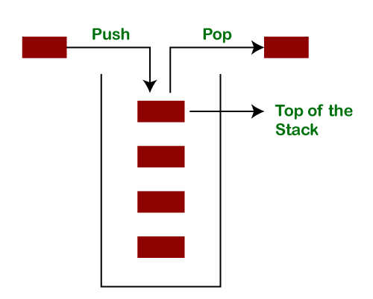

Let's push 20, 13, 89, 90, 11, 45, 18, respectively into the stack.

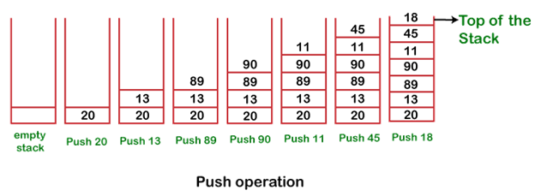

Let's remove (pop) 18, 45, and 11 from the stack.

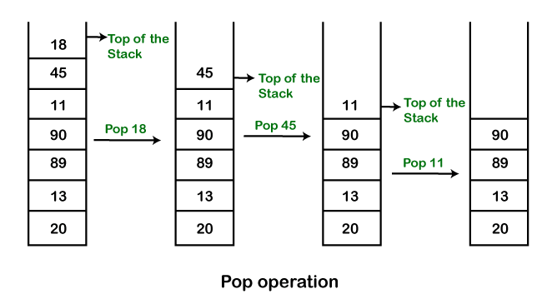

**Empty Stack:** If the stack has no element is known as an **empty stack**. When the stack is empty the value of the top variable is -1.

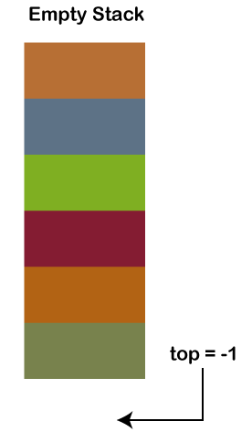

When we push an element into the stack the top is **increased by 1**. In the following figure,

* Push 12, top=0
* Push 6, top=1
* Push 9, top=2

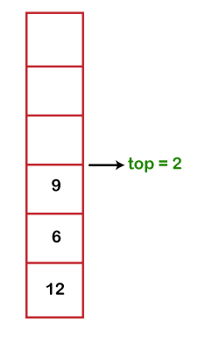

When we pop an element from the stack the value of top is **decreased by 1**. In the following figure, we have popped 9.

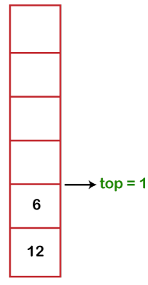

The following table shows the different values of the top.

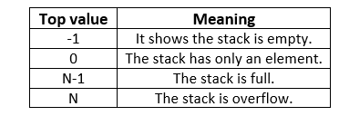

Java Stack Class

In Java, **Stack** is a class that falls under the Collection framework that extends the **Vector** class. It also implements interfaces **List, Collection, Iterable, Cloneable, Serializable.** It represents the LIFO stack of objects. Before using the Stack class, we must import the java.util package. The stack class arranged in the Collections framework hierarchy, as shown below.

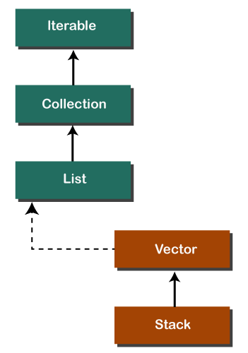

Stack Class Constructor

The Stack class contains only the **default constructor** that creates an empty stack.

1. **public** Stack()

Creating a Stack

If we want to create a stack, first, import the java.util package and create an object of the Stack class.

1. Stack stk = **new** Stack();

Or

1. Stack<type> stk = **new** Stack<>();

Where type denotes the type of stack like Integer, String, etc.

Methods of the Stack Class

We can perform push, pop, peek and search operation on the stack. The Java Stack class provides mainly five methods to perform these operations. Along with this, it also provides all the methods of the [Java Vector class](https://www.javatpoint.com/java-vector).

|  |  |  |
| --- | --- | --- |
| **Method** | **Modifier and Type** | **Method Description** |
| [empty()](https://www.javatpoint.com/java-stack#empty) | boolean | The method checks the stack is empty or not. |
| [push(E item)](https://www.javatpoint.com/java-stack#push) | E | The method pushes (insert) an element onto the top of the stack. |
| [pop()](https://www.javatpoint.com/java-stack#pop) | E | The method removes an element from the top of the stack and returns the same element as the value of that function. |
| [peek()](https://www.javatpoint.com/java-stack#peek) | E | The method looks at the top element of the stack without removing it. |
| [search(Object o)](https://www.javatpoint.com/java-stack#search) | int | The method searches the specified object and returns the position of the object. |

Stack Class empty() Method

The **empty()** method of the Stack class check the stack is empty or not. If the stack is empty, it returns true, else returns false. We can also use the [isEmpty() method of the Vector class](https://www.javatpoint.com/java-vector-isempty-method).

**Syntax**

1. **public** **boolean** empty()

**Returns:** The method returns true if the stack is empty, else returns false.

In the following example, we have created an instance of the Stack class. After that, we have invoked the empty() method two times. The first time it returns **true** because we have not pushed any element into the stack. After that, we have pushed elements into the stack. Again we have invoked the empty() method that returns **false** because the stack is not empty.

**StackEmptyMethodExample.java**

1. **import** java.util.Stack;
2. **public** **class** StackEmptyMethodExample
3. {
4. **public** **static** **void** main(String[] args)
5. {
6. //creating an instance of Stack class
7. Stack<Integer> stk= **new** Stack<>();
8. // checking stack is empty or not
9. **boolean** result = stk.empty();
10. System.out.println("Is the stack empty? " + result);
11. // pushing elements into stack
12. stk.push(78);
13. stk.push(113);
14. stk.push(90);
15. stk.push(120);
16. //prints elements of the stack
17. System.out.println("Elements in Stack: " + stk);
18. result = stk.empty();
19. System.out.println("Is the stack empty? " + result);
20. }
21. }

**Output:**

Is the stack empty? true

Elements in Stack: [78, 113, 90, 120]

Is the stack empty? false

Stack Class push() Method

The method inserts an item onto the top of the stack. It works the same as the method [addElement(item) method](https://www.javatpoint.com/java-vector-addelement-method) of the Vector class. It passes a parameter **item** to be pushed into the stack.

**Syntax**

1. **public** E push(E item)

**Parameter:** An item to be pushed onto the top of the stack.

**Returns:** The method returns the argument that we have passed as a parameter.

Stack Class pop() Method

The method removes an object at the top of the stack and returns the same object. It throws **EmptyStackException** if the stack is empty.

**Syntax**

1. **public** E pop()

**Returns:** It returns an object that is at the top of the stack.

Let's implement the stack in a Java program and perform push and pop operations.

**StackPushPopExample.java**

1. **import** java.util.*;
2. **public** **class** StackPushPopExample
3. {
4. **public** **static** **void** main(String args[])
5. {
6. //creating an object of Stack class
7. Stack <Integer> stk = **new** Stack<>();
8. System.out.println("stack: " + stk);
9. //pushing elements into the stack
10. pushelmnt(stk, 20);
11. pushelmnt(stk, 13);
12. pushelmnt(stk, 89);
13. pushelmnt(stk, 90);
14. pushelmnt(stk, 11);
15. pushelmnt(stk, 45);
16. pushelmnt(stk, 18);
17. //popping elements from the stack
18. popelmnt(stk);
19. popelmnt(stk);
20. //throws exception if the stack is empty
21. **try**
22. {
23. popelmnt(stk);
24. }
25. **catch** (EmptyStackException e)
26. {
27. System.out.println("empty stack");
28. }
29. }
30. //performing push operation
31. **static** **void** pushelmnt(Stack stk, **int** x)
32. {
33. //invoking push() method
34. stk.push(**new** Integer(x));
35. System.out.println("push -> " + x);
36. //prints modified stack
37. System.out.println("stack: " + stk);
38. }
39. //performing pop operation
40. **static** **void** popelmnt(Stack stk)
41. {
42. System.out.print("pop -> ");
43. //invoking pop() method
44. Integer x = (Integer) stk.pop();
45. System.out.println(x);
46. //prints modified stack
47. System.out.println("stack: " + stk);
48. }
49. }

**Output:**

stack: []

push -> 20

stack: [20]

push -> 13

stack: [20, 13]

push -> 89

stack: [20, 13, 89]

push -> 90

stack: [20, 13, 89, 90]

push -> 11

stack: [20, 13, 89, 90, 11]

push -> 45

stack: [20, 13, 89, 90, 11, 45]

push -> 18

stack: [20, 13, 89, 90, 11, 45, 18]

pop -> 18

stack: [20, 13, 89, 90, 11, 45]

pop -> 45

stack: [20, 13, 89, 90, 11]

pop -> 11

stack: [20, 13, 89, 90]

Stack Class peek() Method

It looks at the element that is at the top in the stack. It also throws **EmptyStackException** if the stack is empty.

**Syntax**

1. **public** E peek()

**Returns:** It returns the top elements of the stack.

Let's see an example of the peek() method.

**StackPeekMethodExample.java**

1. **import** java.util.Stack;
2. **public** **class** StackPeekMethodExample
3. {
4. **public** **static** **void** main(String[] args)
5. {
6. Stack<String> stk= **new** Stack<>();
7. // pushing elements into Stack
8. stk.push("Apple");
9. stk.push("Grapes");
10. stk.push("Mango");
11. stk.push("Orange");
12. System.out.println("Stack: " + stk);
13. // Access element from the top of the stack
14. String fruits = stk.peek();
15. //prints stack
16. System.out.println("Element at top: " + fruits);
17. }
18. }

**Output:**

Stack: [Apple, Grapes, Mango, Orange]

Element at the top of the stack: Orange

Stack Class search() Method

The method searches the object in the stack from the top. It parses a parameter that we want to search for. It returns the 1-based location of the object in the stack. Thes topmost object of the stack is considered at distance 1.

Suppose, o is an object in the stack that we want to search for. The method returns the distance from the top of the stack of the occurrence nearest the top of the stack. It uses **equals()** method to search an object in the stack.

**Syntax**

1. **public** **int** search(Object o)

**Parameter:** o is the desired object to be searched.

**Returns:** It returns the object location from the top of the stack. If it returns -1, it means that the object is not on the stack.

Let's see an example of the search() method.

**StackSearchMethodExample.java**

1. **import** java.util.Stack;
2. **public** **class** StackSearchMethodExample
3. {
4. **public** **static** **void** main(String[] args)
5. {
6. Stack<String> stk= **new** Stack<>();
7. //pushing elements into Stack
8. stk.push("Mac Book");
9. stk.push("HP");
10. stk.push("DELL");
11. stk.push("Asus");
12. System.out.println("Stack: " + stk);
13. // Search an element
14. **int** location = stk.search("HP");
15. System.out.println("Location of Dell: " + location);
16. }
17. }

Java Stack Operations

Size of the Stack

We can also find the size of the stack using the [size() method of the Vector class](https://www.javatpoint.com/java-vector-size-method). It returns the total number of elements (size of the stack) in the stack.

**Syntax**

1. **public** **int** size()

Let's see an example of the size() method of the Vector class.

**StackSizeExample.java**

1. **import** java.util.Stack;
2. **public** **class** StackSizeExample
3. {
4. **public** **static** **void** main (String[] args)
5. {
6. Stack stk = **new** Stack();
7. stk.push(22);
8. stk.push(33);
9. stk.push(44);
10. stk.push(55);
11. stk.push(66);
12. // Checks the Stack is empty or not
13. **boolean** rslt=stk.empty();
14. System.out.println("Is the stack empty or not? " +rslt);
15. // Find the size of the Stack
16. **int** x=stk.size();
17. System.out.println("The stack size is: "+x);
18. }
19. }

**Output:**

Is the stack empty or not? false

The stack size is: 5

Iterate Elements

Iterate means to fetch the elements of the stack. We can fetch elements of the stack using three different methods are as follows:

* Using **iterator()** Method
* Using **forEach()** Method
* Using **listIterator()** Method

Using the iterator() Method

It is the method of the Iterator interface. It returns an iterator over the elements in the stack. Before using the iterator() method import the java.util.Iterator package.

**Syntax**

1. Iterator<T> iterator()

Let's perform an iteration over the stack.

**StackIterationExample1.java**

1. **import** java.util.Iterator;
2. **import** java.util.Stack;
3. **public** **class** StackIterationExample1
4. {
5. **public** **static** **void** main (String[] args)
6. {
7. //creating an object of Stack class
8. Stack stk = **new** Stack();
9. //pushing elements into stack
10. stk.push("BMW");
11. stk.push("Audi");
12. stk.push("Ferrari");
13. stk.push("Bugatti");
14. stk.push("Jaguar");
15. //iteration over the stack
16. Iterator iterator = stk.iterator();
17. **while**(iterator.hasNext())
18. {
19. Object values = iterator.next();
20. System.out.println(values);
21. }
22. }
23. }

**Output:**

BMW

Audi

Ferrari

Bugatti

Jaguar

Using the forEach() Method

Java provides a forEach() method to iterate over the elements. The method is defined in the **Iterable** and **Stream** interface.

**Syntax**

1. **default** **void** forEach(Consumer<**super** T>action)

Let's iterate over the stack using the forEach() method.

**StackIterationExample2.java**

1. **import** java.util.*;
2. **public** **class** StackIterationExample2
3. {
4. **public** **static** **void** main (String[] args)
5. {
6. //creating an instance of Stack class
7. Stack <Integer> stk = **new** Stack<>();
8. //pushing elements into stack
9. stk.push(119);
10. stk.push(203);
11. stk.push(988);
12. System.out.println("Iteration over the stack using forEach() Method:");
13. //invoking forEach() method for iteration over the stack
14. stk.forEach(n ->
15. {
16. System.out.println(n);
17. });
18. }
19. }

**Output:**

Iteration over the stack using forEach() Method:

119

203

988

Using listIterator() Method

This method returns a list iterator over the elements in the mentioned list (in sequence), starting at the specified position in the list. It iterates the stack from top to bottom.

**Syntax**

1. ListIterator listIterator(**int** index)

**Parameter:** The method parses a parameter named **index.**

**Returns:** This method returns a list iterator over the elements, in sequence.

**Exception:** It throws **IndexOutOfBoundsException** if the index is out of range.

Let's iterate over the stack using the listIterator() method.

**StackIterationExample3.java**

1. **import** java.util.Iterator;
2. **import** java.util.ListIterator;
3. **import** java.util.Stack;
5. **public** **class** StackIterationExample3
6. {
7. **public** **static** **void** main (String[] args)
8. {
9. Stack <Integer> stk = **new** Stack<>();
10. stk.push(119);
11. stk.push(203);
12. stk.push(988);
13. ListIterator<Integer> ListIterator = stk.listIterator(stk.size());
14. System.out.println("Iteration over the Stack from top to bottom:");
15. **while** (ListIterator.hasPrevious())
16. {
17. Integer avg = ListIterator.previous();
18. System.out.println(avg);
19. }
20. }
21. }

**Output:**

Iteration over the Stack from top to bottom:

988

203

119